Project Design Phase-II
Data Flow Diagram & User Stories

Date | 18 June 2026
Student Name | Ch.Sai Shruthi
Project Name | ShopEz
Maximum Marks | 4 Marks

Data Flow Diagrams:
A Data Flow Diagram (DFD) is a traditional visual representation of the information flows within a system. A neat and clear DFD can depict the right amount of the system requirement graphically. It shows how data enters and leaves the system, what changes the information, and where data is stored.

Example: (Simplified)
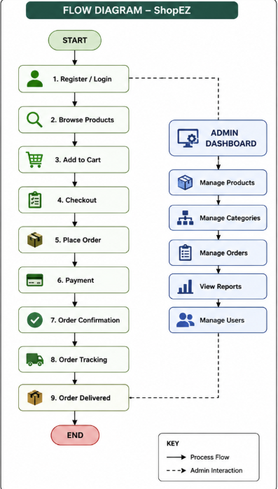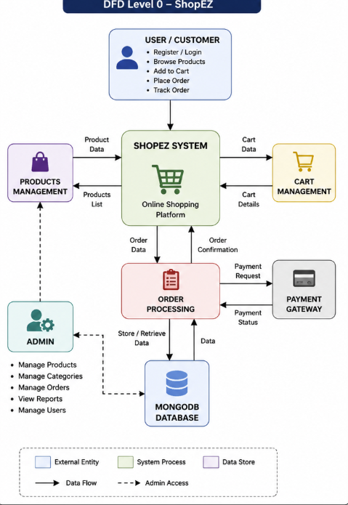

User Stories
Use the below template to list all the user stories for the product.
User Type | Functional Requirement (Epic) | User Story Number | User Story / Task | Acceptance criteria | Priority | Release
Customer (Web/Mobile User) | Registration | USN-1 | As a user, I can register for the application by entering my email, password, and confirming my password. | User account is created successfully. | High | Sprint-1
Customer (Web/Mobile User) | Login | USN-2 | As a user, I can log in using email and password. | User can access dashboard/profile. | High | Sprint-1
Customer (Web/Mobile User) | Product Catalog | USN-3 | As a user, I can browse available products. | Products are displayed correctly. | High | Sprint-1
Customer (Web/Mobile User) | Product Search | USN-4 | As a user, I can search products by name or category. | Relevant products are displayed. | Medium | Sprint-2
Customer (Web/Mobile User) | Shopping Cart | USN-5 | As a user, I can add products to my cart. | Product is added successfully. | High | Sprint-2
Customer (Web/Mobile User) | Shopping Cart | USN-6 | As a user, I can remove products from my cart. | Product is removed successfully. | Medium | Sprint-2
Customer (Web user) | Order Placement | USN-7 | As a user, I can place an order. | Order is created successfully. | High | Sprint-3
Customer Care Executive | Order Tracking | USN-8 | As a user, I can track my orders. | Order status is visible. | Medium | Sprint-3
Customer Care Executive | Customer Support | USN-9 | As a support executive, I can view customer orders and assist users. | Customer issues can be resolved. | Medium | Sprint-3
Administrator | Product Management  t | USN-10 | As an admin, I can add, update, and delete products. |  | High | Sprint-4
Administrator | Category Management | USN-11 | As an admin, I can manage product categories. |  | Medium | Sprint-4
Administrator | Order Management | USN-12 | As an admin, I can view and manage all orders. | Orders can be processed and updated. | High | Sprint-4

